The hardware of this project is subdivided in two elements: the PCB and the accelerometer.

The PCB is composed by: PSoC, Bluetooth module (HC-06), 9V battery and LEDs, and is inserted into a 3D printed case.

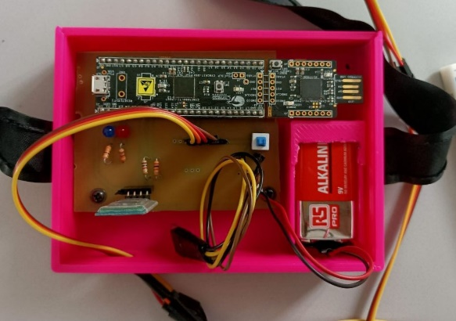

The accelerometer is a LIS3DH and is mounted on a band which will be applied to the thorax of the subject, and is connected to the PCB through long cables.

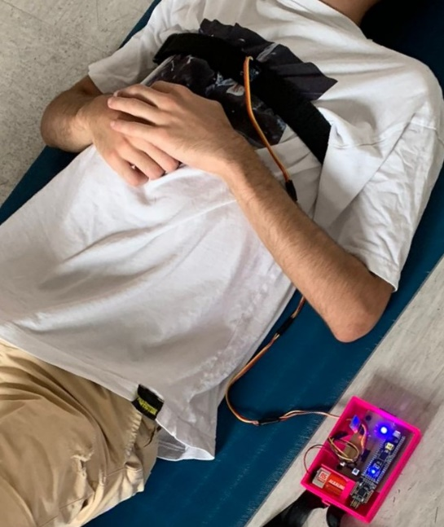

The connections of the components to the pin of the PSOC are:

|  |  |
| --- | --- |
| Component | Pin |
| HC-06 RX | 2.7 |
| HC-06 TX | 2.6 |
| LIS3DH SCL | 12.0 |
| LIS3DH SDA | 12.1 |
| STATUS LED (BLUE) | 2.1 |
| ERROR LED (RED) | 2.2 |

The band needs to be applied on the chest of the subject and tight in, with the LIS3DH in central position and the 6 pins on the upper side. The case with the PCB is kept near the subject.